Title {Style: Arial 12 Bold}

J.M. Smith ¹, S. A. Robinson ², {Style: Arial 10 Bold}

- ISIS, Rutherford Appleton Lab, OX11 0QX Harwell-Oxford, UK
- School of Physics and Astronomy, University of Leeds, LS2 9JT, Leeds, UK
{Style: Arial 9 Italic}
Abstract {Style: Arial 10 Bold}
Write your abstract here with a maximum extension of 2,000 characters (spacing included).
{Style: Arial 10 Regular}
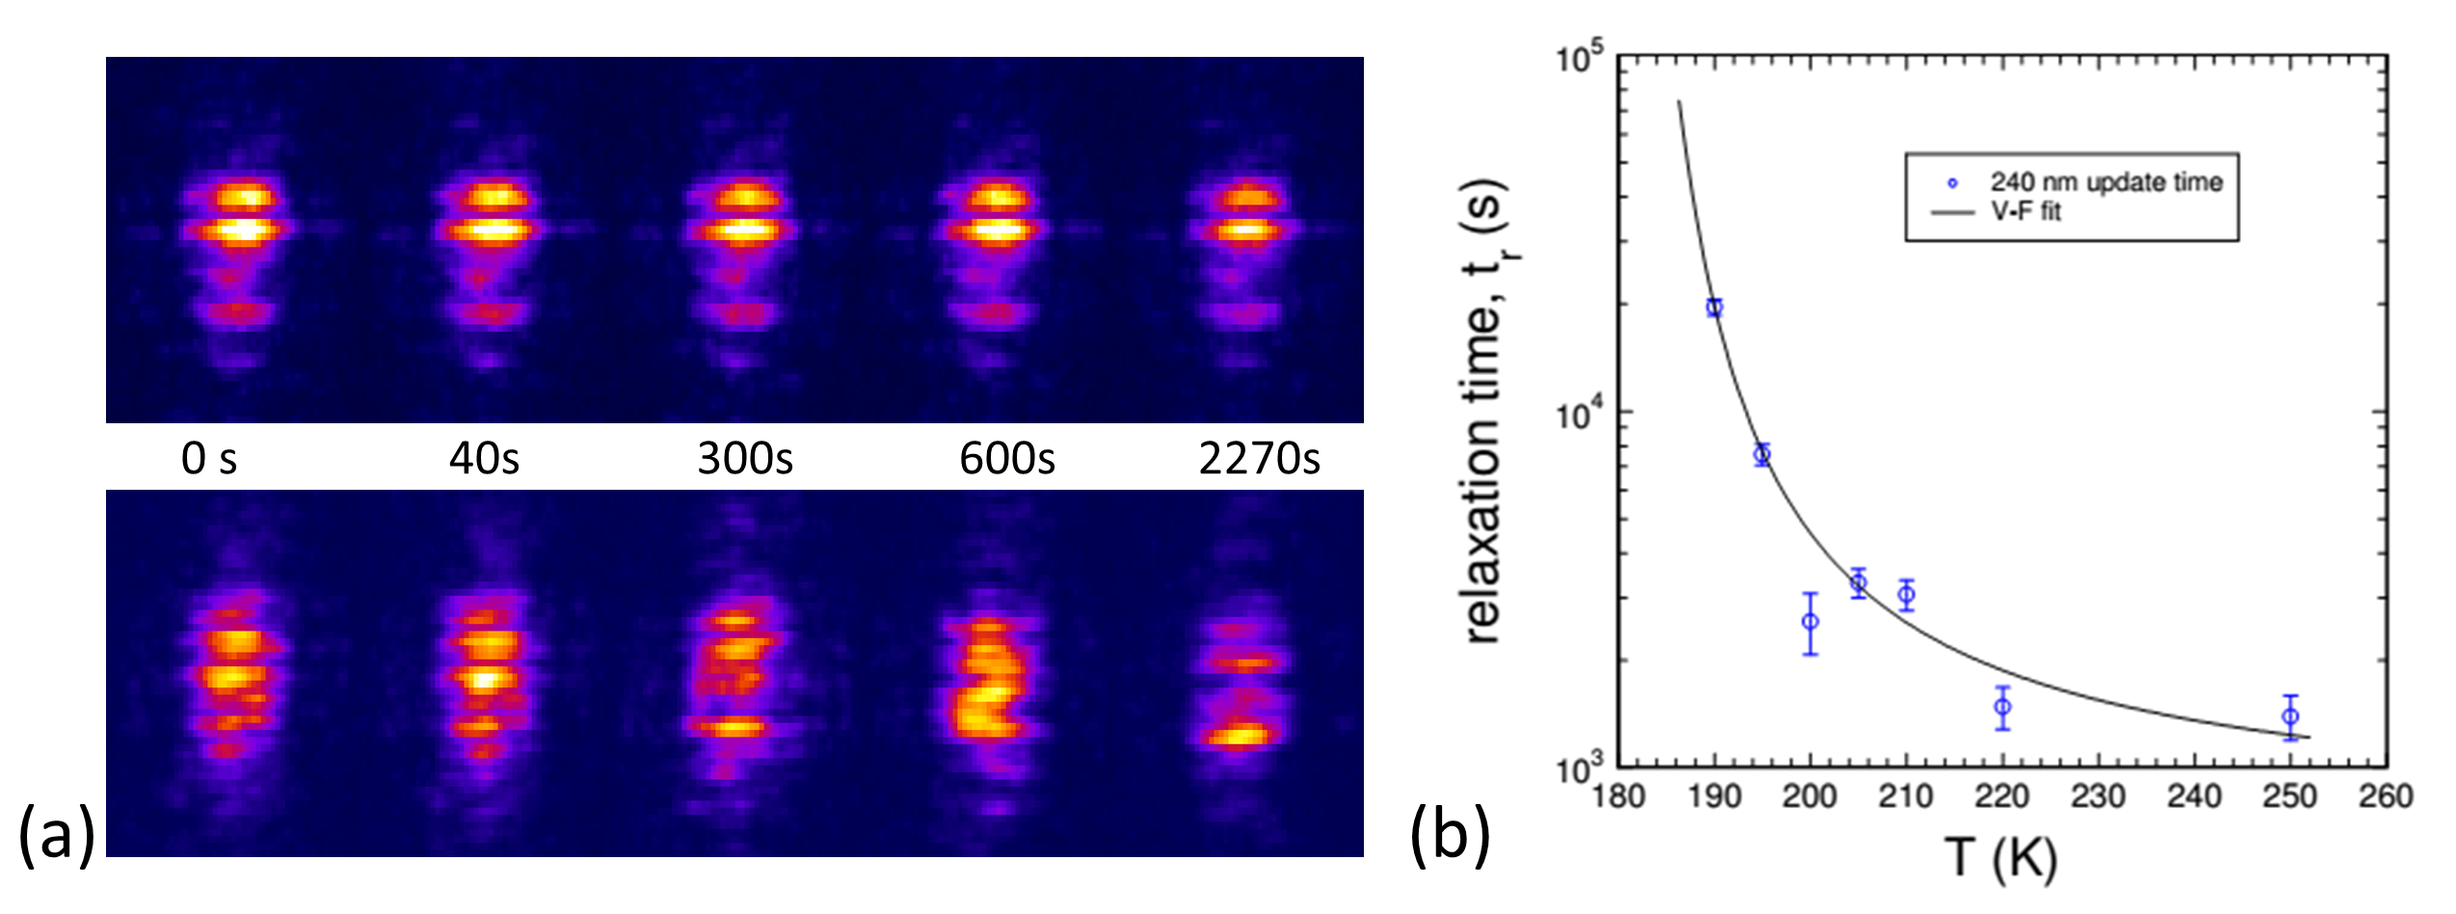
Fig.1: (a) Comment on image A (b) Comment on image A
{Style: Arial 10 Regular}

References {Style: Arial 10 Bold}
[1] R.F. Wang et al., Nature 439, 303 (2006)
[2] V. Kapaklis et al., Nat. Nano. 9, 514 (2014)
[3] S. Zhang et al., Nature 500, 7464 (2013)
[4] A. Farhan et al., Nat. Phys. 9, 375 (2013)
{Style: Arial 8 Regular}

---------------
IMPORTANT NOTE:
Abstracts must have a maximum length of one page.

